KLH1 -

Functionality

Activity Types can be grouped to facilitate reporting and cost allocation.

Scenario

This system task is used to create an activity type grouping.

Requirements
Activity types must be created.

Menu Path | Accounting → Controlling → Cost Center Accounting → Master Data → Activity Type Group → KLH1 - Create → KLH1 - Create
Transaction Code | KLH1

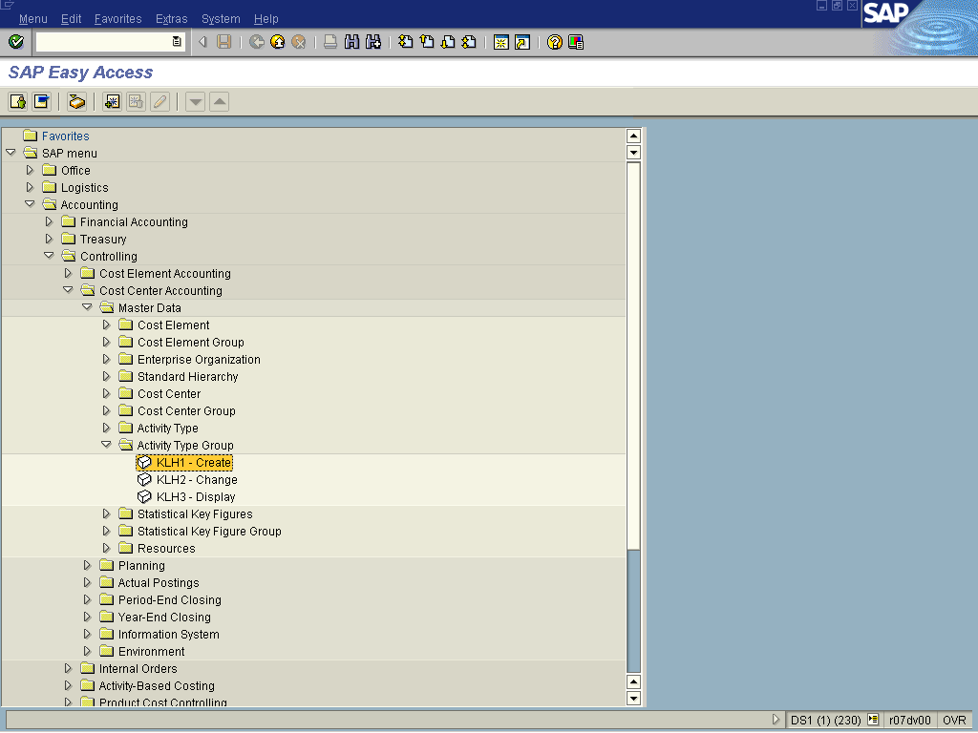

1. Double Click on KLH1 - Create

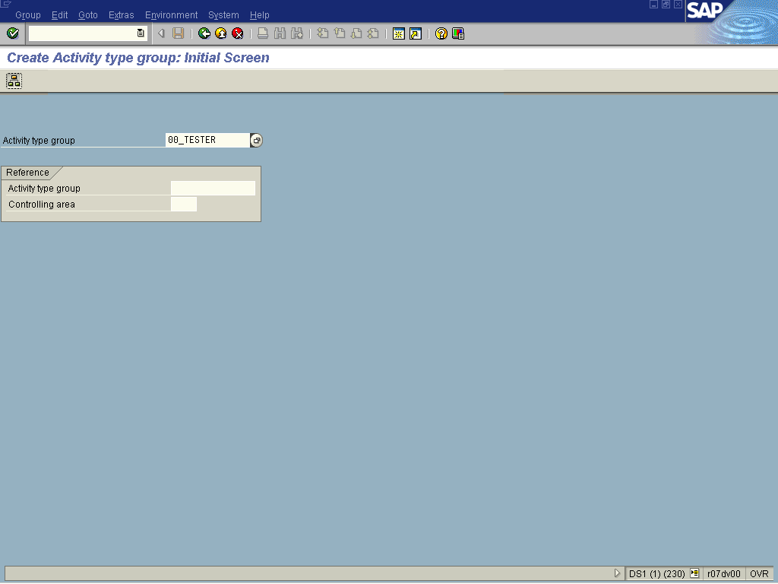

2. Update the following fields:

Field Name | Field Description | Values
Activity type group | Activity types describe the activity produced by a cost center and are measured in units of time or quantity. | Example: 00_TESTER

3. Click Display menu of an activity group Button .

4. Update the following fields:

Field Name | Field Description | Values
Description | Description of the activity group. | Example: 00_TESTER Test Group

5. Click on the 00_TESTER text once.
6. Click Lower level Button .
7. Update the following fields:

Field Name | Field Description | Values
Name | Name of the activity sub group. | Example: 00_PRD
Description | Description of the activity sub group. | Example: Production Test Group

8. Click Activity Type Button .
9. Update the following fields:

Field Name | Field Description | Values
From Activity | Activity type field. | Example: 1pd00
To Activity | Activity type field. | Example: 1pd99

10. Click 00_PRD text.
11. Click Same level Button .
12. Update the following fields:

Field Name | Field Description | Values
Name | Name of the activity sub group. | Example: 00_RnT
Description | Description of the activity sub group. | Example: Research and Technology

13. Click 00_RNT text.
14. Click Activity Type Button .
15. Update the following fields:

Field Name | Field Description | Values
From Activity | Activity type field. | Example: 1rt00
To Activity | Activity type field. | Example: 1rt99
16. Click Save
Information
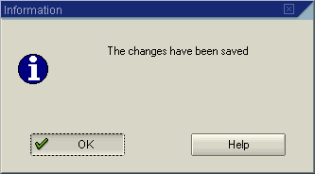
17. Click OK Button .
Create Activity type group: Structure

